What types of mutations cause more vs. less severe muscular dystrophy?

To learn why 17-year-old Jake needs to use a wheelchair, watch “Duchenne Muscular Dystrophy” (https://www.youtube.com/watch?v=CkbaEjpxQ3g).

Duchenne muscular dystrophy is caused by a defective version of the DMD gene. This gene gives the instructions for making the dystrophin protein. Normal dystrophin keeps muscle cells healthy. If there is no functional dystrophin, muscle cells gradually die, so the muscles get weaker and weaker.

1. Complete this chart to explain how a mutated gene can result in the inability to walk.

Gene in DNA | → | Protein | → | Characteristics
Normal version of the DMD gene gives the instructions for making normal dystrophin protein. | → | Normal dystrophin  in muscle cells | → | Healthy muscle cells →  normal walking
A mutated version of the DMD gene gives the instructions for making a non-functional dystrophin protein. | → | No functional  _____________  in muscle cells | →

Mutations have resulted in many different versions of the DMD gene. Some of these mutated versions of the DMD gene cause Duchenne muscular dystrophy. Other mutated versions of the DMD gene cause a milder disease, called Becker muscular dystrophy.

In Duchenne muscular dystrophy, muscle cells do not have any functional dystrophin, so many muscle cells die during childhood. A boy with Duchenne muscular dystrophy typically needs to use a wheelchair by age 12. As he gets older, more and more heart and breathing muscle cells die. This causes heart and breathing problems, which generally result in death by age 30.

In Becker muscular dystrophy, muscle cells have a defective version of dystrophin that is somewhat effective for keeping muscle cells alive. A man with Becker muscular dystrophy often does not need a wheelchair until his thirties and survives into his forties.

2. Many cases of both types of muscular dystrophy are caused by mutations that delete one or more nucleotides from the DMD gene. What do you think is the main difference between the types of deletion mutations that cause Duchenne vs. Becker muscular dystrophy?

To understand the difference between the types of mutations that cause Duchenne vs. Becker muscular dystrophy, we need to review how a gene gives the instructions for making a protein.

This figure summarizes how a gene gives the instructions for making a protein. The figure shows short segments of the molecules involved in transcription and translation.  3a. Fill in the blanks with the molecules produced by transcription and translation.  3b. Circle a nucleotide in the part of the gene shown in the figure. | 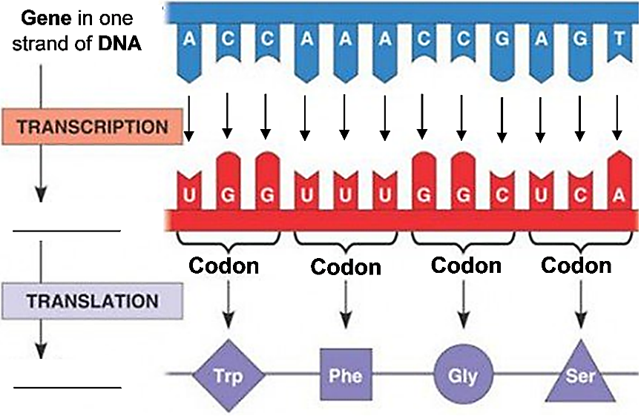

3c. Which other molecule in the figure is a polymer of nucleotides?

3d. Draw a rectangle around a single amino acid.

4a. Which process occurs in the nucleus? transcription ___ translation ___

4b. Which process occurs in ribosomes? transcription ___ translation ___

5. Each nucleotide contains a base. Transcription depends on the base-pairing rules:
A in DNA always pairs with ___ in mRNA.
T in DNA always pairs with ___ in mRNA.
G always pairs with ___.

6a. Base-pairing rules also apply during translation when an mRNA codon is matched with a tRNA anti-codon. To complete this diagram of a tRNA, label the nucleotides in the anti-codon for Ser. (Hint: See the figure above, which gives the mRNA codon for Ser.)

6b. Add a Ser amino acid to the tRNA.

7a. Complete this diagram to show how a gene in the DNA gives the instructions for making a protein. Sketch and label:
- DNA with a gene and mRNA
- a ribosome making a protein with the help of mRNA and tRNA.

7b. Draw a rectangle around the process of transcription. Circle the process of translation.

This figure shows how a ribosome makes a protein. During translation, the codon UUU in mRNA directs the ribosome to add the amino acid phe = phenylalanine to the growing protein.

8. Circle the UUU codon in the mRNA molecule. Write phe in the blank rectangle that represents the amino acid that has just been added to the growing protein.

In the cytoplasm, enzymes bind each tRNA to the appropriate amino acid for its anti-codon. For example, an enzyme binds a tRNA with
the AAA anti-codon to the phe amino acid. When the ribosome reaches a UUU codon in the mRNA, this tRNA brings the phe amino acid to be added to the growing protein.

9a. Draw an arrow from the tRNA in the cytoplasm to the same tRNA in the ribosome.

9b. Explain how a ribosome, tRNA molecules, and the base-pairing rules cooperate to add the correct amino acid for each codon in the mRNA molecule.

The codon wheel shown below summarizes which amino acid corresponds to each codon in mRNA. The amino acids are shown in the outer circle of the codon wheel. To identify the codons that specify an amino acid, start from the center where the first nucleotide in a codon is shown and move outward to the second and third nucleotides in the codon.

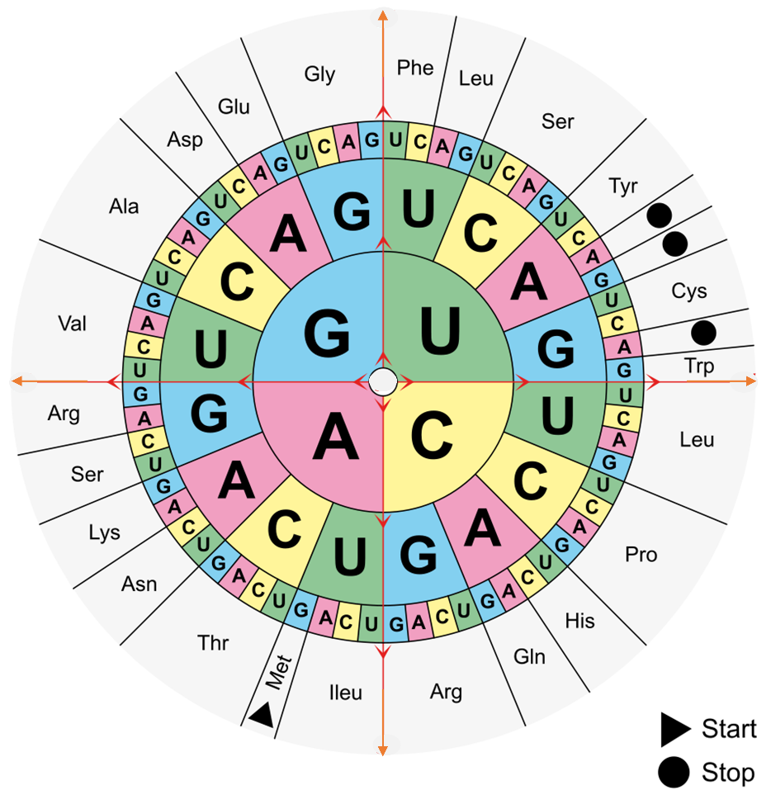 | 10a. Circle the amino acid Ser (serine; near the top right-hand corner).  10b. The codons that code for the amino acid Ser are UCU, UCC,  ______ and ______.  11. Draw a line around the part of the codon wheel that shows that UUU is a codon for Phe = phe = phenylalanine.  12. Translation of an mRNA molecule begins at the start codon (AUG). Translation ends at a stop codon. The stop codons are UAA,  ______ and ______.
13a. The first column of the table below shows the beginning of the normal version of a gene and three different deletion mutations. Use the base-pairing rules to complete the second column of the table. For each deletion mutation, use check marks to indicate any mRNA codons that will not be changed by the mutation and write in any codons that will be changed.

Beginning of gene in DNA | Beginning codons in mRNA produced by transcription | Beginning amino acids in protein produced by translation
Normal version of gene =  TACCGAAGATCCTGA…* | AUG GCU UCU AGG ACU… | Met – Ala – Ser – Arg – Thr…
Deletion mutation 1 =  TACCGAGATCCTGA…  (3rd A in the gene is deleted) | ___ ___ ___ ___ ___… | ___ ___ ___ ___ ___…
Deletion mutation 2 =  TACCGAATCCTGA…  (3rd A & 2nd G deleted) | ___ ___ ___ ___ ___… | ___ ___ ___ ___ ___…
Deletion mutation 3 =  TACCGATCCTGA…  (3rd & 4th A & 2nd G deleted) | ___ ___ ___ ___ ___… | ___ ___ ___ ___ ___…
*In the deletion mutations, 1, 2 or 3 of the underlined nucleotides are deleted.

13b. Use the codon wheel to circle any stop codons in the partial mRNA molecules in the above table.  13c. Complete the last column of the above table. Use checkmarks to indicate any amino acids that will remain the same and dashes to indicate any amino acids that will be missing as a result of an early stop codon. Write in any amino acids that will be changed.  14a. Match each deletion mutation in the top list with the best match from the bottom list.  Deletion mutation 1 ___  Deletion mutation 2 ___  Deletion mutation 3 ___ | 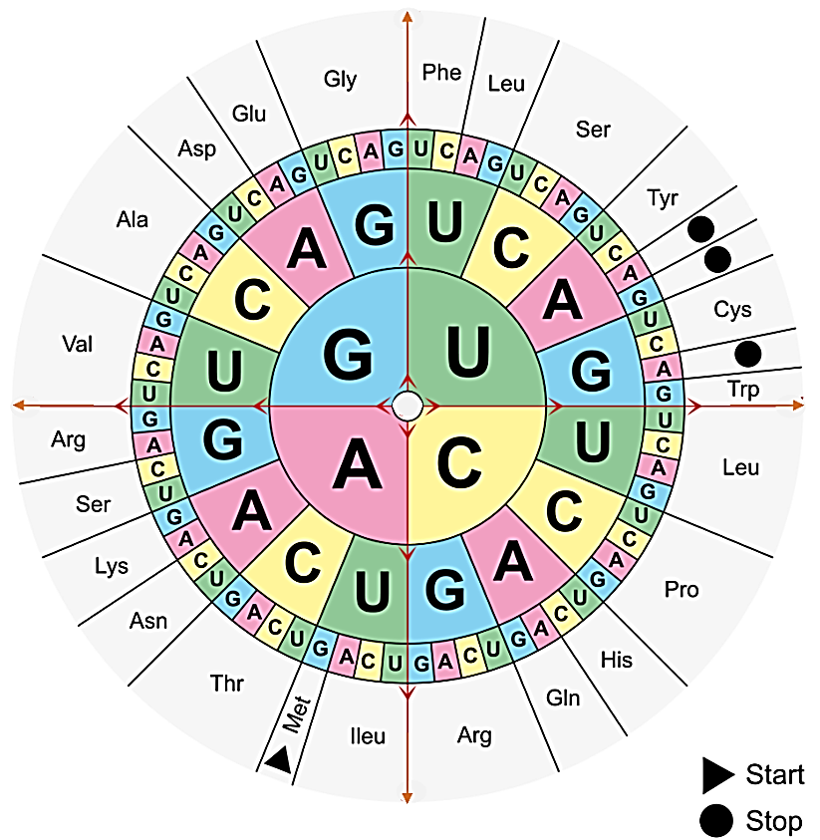

- Early stop codon, so no functional protein
- After the first two amino acids, each subsequent amino acid will be different, so the protein will not be functional.
- One amino acid is missing, but, after that, the sequence of amino acids is the same, so the protein very likely will have somewhat normal function.

14b. Explain how one of the deletion mutations resulted in the same sequence of amino acids, except with one amino acid missing.

15a. The majority of cases of muscular dystrophy are caused by a deletion mutation. These deletion mutations can be grouped into two categories:
- The number of nucleotides missing from the mRNA is a multiple of 3.
- The number of nucleotides missing from the mRNA is not a multiple of 3.

Which type of mutation causes the more severe Duchenne muscular dystrophy? ____
Which type of mutation causes the milder Becker muscular dystrophy? _____

15b. Explain your reasoning.

16. A point mutation is a change in a single nucleotide in a gene. What type of point mutation could result in Duchenne muscular dystrophy?

About one third of cases of Duchenne and Becker muscular dystrophy are caused by a new mutation, and about two thirds are caused by an inherited allele due to a previous mutation.

Duchenne muscular dystrophy is very rare in girls, and almost all Duchenne muscular dystrophy patients are boys. To understand why, see the explanation below.

The DMD gene is located on the X chromosome. The much shorter Y chromosome does not have the DMD gene.  17a. The carrier mother has one normal DMD gene and one mutated DMD gene in every cell in her body. She does not have muscular dystrophy. This tells you that the normal version  of the DMD gene is _________________ and  (dominant / recessive)  the mutated version of the DMD gene is  _________________.  (dominant / recessive)  17b. Use this information to explain why almost all Duchenne muscular dystrophy patients are boys and Duchenne muscular dystrophy is very rare in girls. | 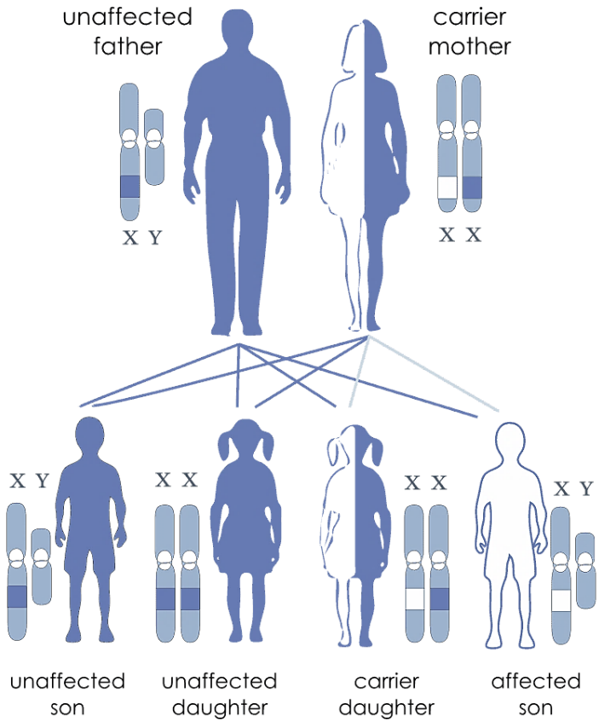  The affected son has Duchenne muscular dystrophy because he does not have a normal DMD gene that provides the instructions for making functional dystrophin.

By Dr. Ingrid Waldron, Department of Biology, University of Pennsylvania, © 2024. This Student Handout and Teacher Notes (with instructional suggestions and biology background) are available at https://serendipstudio.org/exchange/bioactivities/mutation.

